Suggested Virtual Learning Books

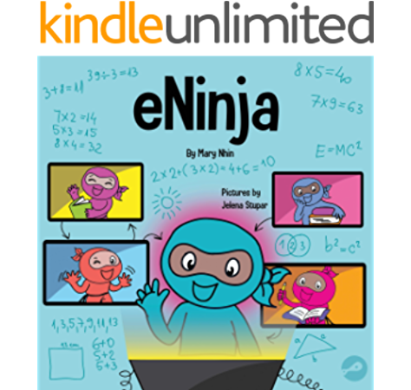

eNinja: A Children’s Book About Virtual Learning Practices for Online Student Success by Mary Nhin

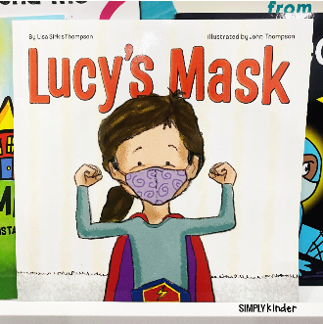

Lucy’s Mask by Lisa Sirkis Thompson

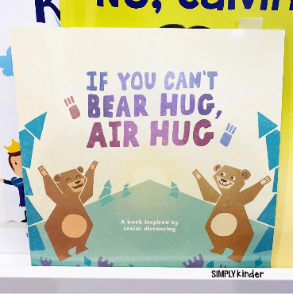

If You Can’t Bear Hug, Air Hug by Katie Sedmak

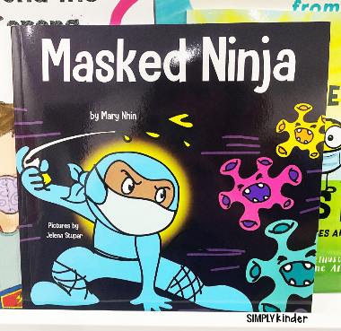

Masked Ninja by Mary Nhin

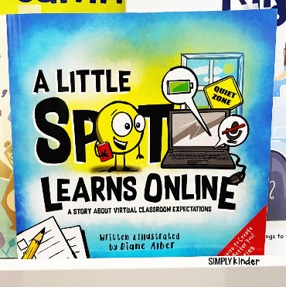

A Little Spot Learns Online by Diane Alber

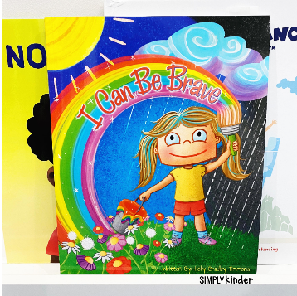

I Can Be Brave by Holly Bradley Timmons